How Does Hadoop Work?
It is quite expensive to build bigger servers with heavy configurations that handle large scale processing, but as an alternative, you can tie together many commodity computers with single-CPU, as a single functional distributed system and practically, the clustered machines can read the dataset in parallel and provide a much higher throughput.
Moreover, it is cheaper than one high-end server. So this is the first motivational factor behind using Hadoop that it runs across clustered and low-cost machines.
Hadoop runs code across a cluster of computers. This process includes the following core tasks that Hadoop performs −
- Data is initially divided into directories and files. Files are divided into uniform sized blocks of 128M and 64M (preferably 128M).
- These files are then distributed across various cluster nodes for further processing.
- HDFS, being on top of the local file system, supervises the processing.
- Blocks are replicated for handling hardware failure.
- Checking that the code was executed successfully.
- Performing the sort that takes place between the map and reduce stages.
- Sending the sorted data to a certain computer.
- Writing the debugging logs for each job.

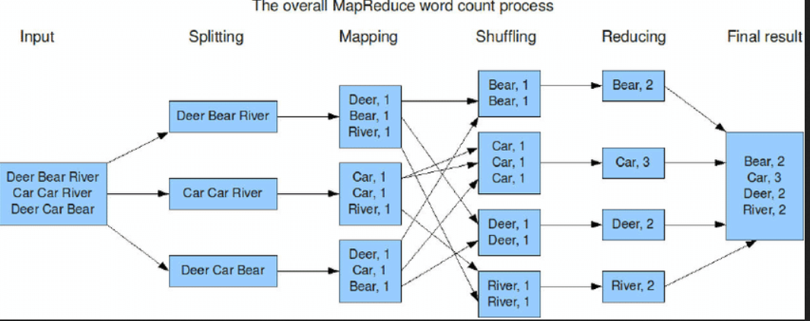
NameNodes (master) and DataNodes (slaves) are core components of the HDFS architecture, with the NameNode managing file system metadata (location, permissions) in memory. DataNodes handle actual data storage, block creation, and replication, performing I/O tasks instructed by the NameNode.
------------------------------------------------
Hadoop is a free, open-source software framework used to store and process massive amounts of data (Big Data) across clusters of inexpensive computers. Instead of using one giant, expensive computer, Hadoop connects many small ones (called nodes) to work together as a single system.
Core Components
Hadoop is built on four primary modules that handle different parts of the job:
- HDFS (Hadoop Distributed File System): The storage layer. It breaks large files into smaller "blocks" and spreads them across different machines in the cluster.
- MapReduce: The processing layer. It breaks a large task into smaller sub-tasks, processes them in parallel across the machines (Map), and then combines the results (Reduce).
- YARN (Yet Another Resource Negotiator): The resource manager. It acts like an operating system for the cluster, deciding which applications get which resources (like CPU and memory) and when.
- Hadoop Common: A set of shared libraries and utilities that support the other modules and help them work together.
Key Features
- Cost-Effective: It runs on "commodity hardware" (standard, low-cost computers) rather than high-end servers.
- Fault Tolerance: It automatically makes multiple copies (usually three) of every data block. If one machine fails, the data is still safe on others, and the system keeps running.
- Scalability: You can easily grow your system by simply adding more computers to the cluster without any downtime.
- Flexibility: It can handle any type of data—structured (tables), semi-structured (XML/JSON), or unstructured (images, videos, text).

Real-World Examples and Applications
- Social Media Analytics:
- Search Engines:
- Log Analysis: Data Mining and ETL:
- Recommendation Systems:

--------------------------------------

Step 1: Install prerequisites
- Install Docker Desktop for Windows:
  - https://www.docker.com/products/docker-desktop
- Make sure WSL2 is enabled if using Windows Home.
- Open PowerShell or CMD.
Check Docker works:
docker --version
docker ps

Step 2: Create project folder
mkdir C:\hadoop-docker
cd C:\hadoop-docker
Inside this folder, create docker-compose.yml.

Step 3: Docker Compose configuration
Create docker-compose.yml:
====================================================
version: "3.8"

services:
namenode:
image: bde2020/hadoop-namenode:2.0.0-hadoop3.2.1-java8
container_name: namenode
environment:
- CLUSTER_NAME=test
- CORE_CONF_fs_defaultFS=hdfs://namenode:9000
- HDFS_CONF_dfs_replication=1
- HDFS_CONF_dfs_permissions_enabled=false
ports:
- "9870:9870"
- "9000:9000"
volumes:
- namenode:/hadoop/dfs/name

datanode:
image: bde2020/hadoop-datanode:2.0.0-hadoop3.2.1-java8
container_name: datanode
depends_on:
- namenode
environment:
- CLUSTER_NAME=test
- CORE_CONF_fs_defaultFS=hdfs://namenode:9000
- SERVICE_PRECONDITION=namenode:9870
- HDFS_CONF_dfs_datanode_data_dir=file:///hadoop/dfs/data
volumes:
- datanode:/hadoop/dfs/data

resourcemanager:
image: bde2020/hadoop-resourcemanager:2.0.0-hadoop3.2.1-java8
container_name: resourcemanager
depends_on:
- namenode
- datanode
environment:
- CORE_CONF_fs_defaultFS=hdfs://namenode:9000
ports:
- "8088:8088"

volumes:
namenode:
datanode:
Note: This is the minimal single-node setup.

Step 4: Start Hadoop cluster
In PowerShell:
docker-compose up -d
Check containers:
docker ps
Expected containers: namenode, datanode, resourcemanager, nodemanager.
- NameNode UI: http://localhost:9870
- YARN UI: http://localhost:8088

Step 5: Prepare HDFS input
- Create a local input file:
mkdir input
echo "hello hadoop hello docker" > input/file.txt
- Copy the file to the NameNode container:
docker cp .\input\file.txt namenode:/tmp/file.txt
- Put file into HDFS:
docker exec -it namenode hdfs dfs -mkdir -p /input
docker exec -it namenode hdfs dfs -put /tmp/file.txt /input
Check HDFS:
docker exec -it namenode hdfs dfs -ls /input

Step 6: Create Hadoop MapReduce WordCount in Java
Folder structure in Eclipse:
WordCountProject/
└─ src/
└─ wordcount/
└─ WordCount.java
└─ lib/ <-- all Hadoop jars go here
WordCount.java:
package wordcount;
import org.apache.hadoop.conf.Configuration;
import org.apache.hadoop.fs.Path;
import org.apache.hadoop.io.IntWritable;
import org.apache.hadoop.io.Text;
import org.apache.hadoop.mapreduce.Job;
import org.apache.hadoop.mapreduce.Mapper;
import org.apache.hadoop.mapreduce.Reducer;
import org.apache.hadoop.mapreduce.lib.input.FileInputFormat;
import org.apache.hadoop.mapreduce.lib.output.FileOutputFormat;
import java.io.IOException;
import java.util.StringTokenizer;
public class WordCount {
public static class TokenizerMapper
extends Mapper<Object, Text, Text, IntWritable> {
private final static IntWritable one = new IntWritable(1);
private Text word = new Text();
public void map(Object key, Text value, Context context
) throws IOException, InterruptedException {
StringTokenizer itr = new StringTokenizer(value.toString());
while (itr.hasMoreTokens()) {
word.set(itr.nextToken().replaceAll("[^a-zA-Z]", "").toLowerCase());
context.write(word, one);
}
}
}
public static class IntSumReducer
extends Reducer<Text, IntWritable, Text, IntWritable> {
private IntWritable result = new IntWritable();
public void reduce(Text key, Iterable<IntWritable> values,
Context context) throws IOException, InterruptedException {
int sum = 0;
for (IntWritable val : values) sum += val.get();
result.set(sum);
context.write(key, result);
}
}
public static void main(String[] args) throws Exception {
Configuration conf = new Configuration();
Job job = Job.getInstance(conf, "word count");
job.setJarByClass(WordCount.class);
job.setMapperClass(TokenizerMapper.class);
job.setCombinerClass(IntSumReducer.class);
job.setReducerClass(IntSumReducer.class);
job.setOutputKeyClass(Text.class);
job.setOutputValueClass(IntWritable.class);
FileInputFormat.addInputPath(job, new Path(args[0]));
FileOutputFormat.setOutputPath(job, new Path(args[1]));
System.exit(job.waitForCompletion(true) ? 0 : 1);
}
}

Step 7: Export as runnable jar
- In Eclipse: Export → Runnable Jar file
- Put all required Hadoop MapReduce jars in the build path (lib folder).
- Save as wcjar.jar.
Copy jar to NameNode container:
docker cp C:\hadoop-docker\wcjar.jar namenode:/wcjar.jar

Step 8: Run the Hadoop MapReduce job
docker exec -it namenode hadoop jar /wcjar.jar wordcount.WordCount /input /output
Check output:
docker exec -it namenode hdfs dfs -cat /output/part-r-00000
Expected output:
docker 1
hadoop 1
hello 2

✅ Step 9: Cleanup
- Remove HDFS output before re-running:
docker exec -it namenode hdfs dfs -rm -r /output
- Stop cluster:
docker-compose down

This is the full workflow from scratch on Windows using Docker: cluster setup → HDFS → MapReduce job → output.

